

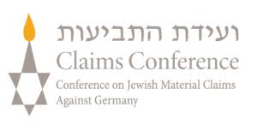



Seminar venue

Participants
50 teachers

Languages
English

Coordinators and moderators
Esther Mucznik, Memoshoa
Loranda Miletić, ETTA
Maria Ojuel, Department of Education, Government of Catalonia
David González, EUROM
Gemma Simon, Memorial Democràtic, Generalitat de Catalunya
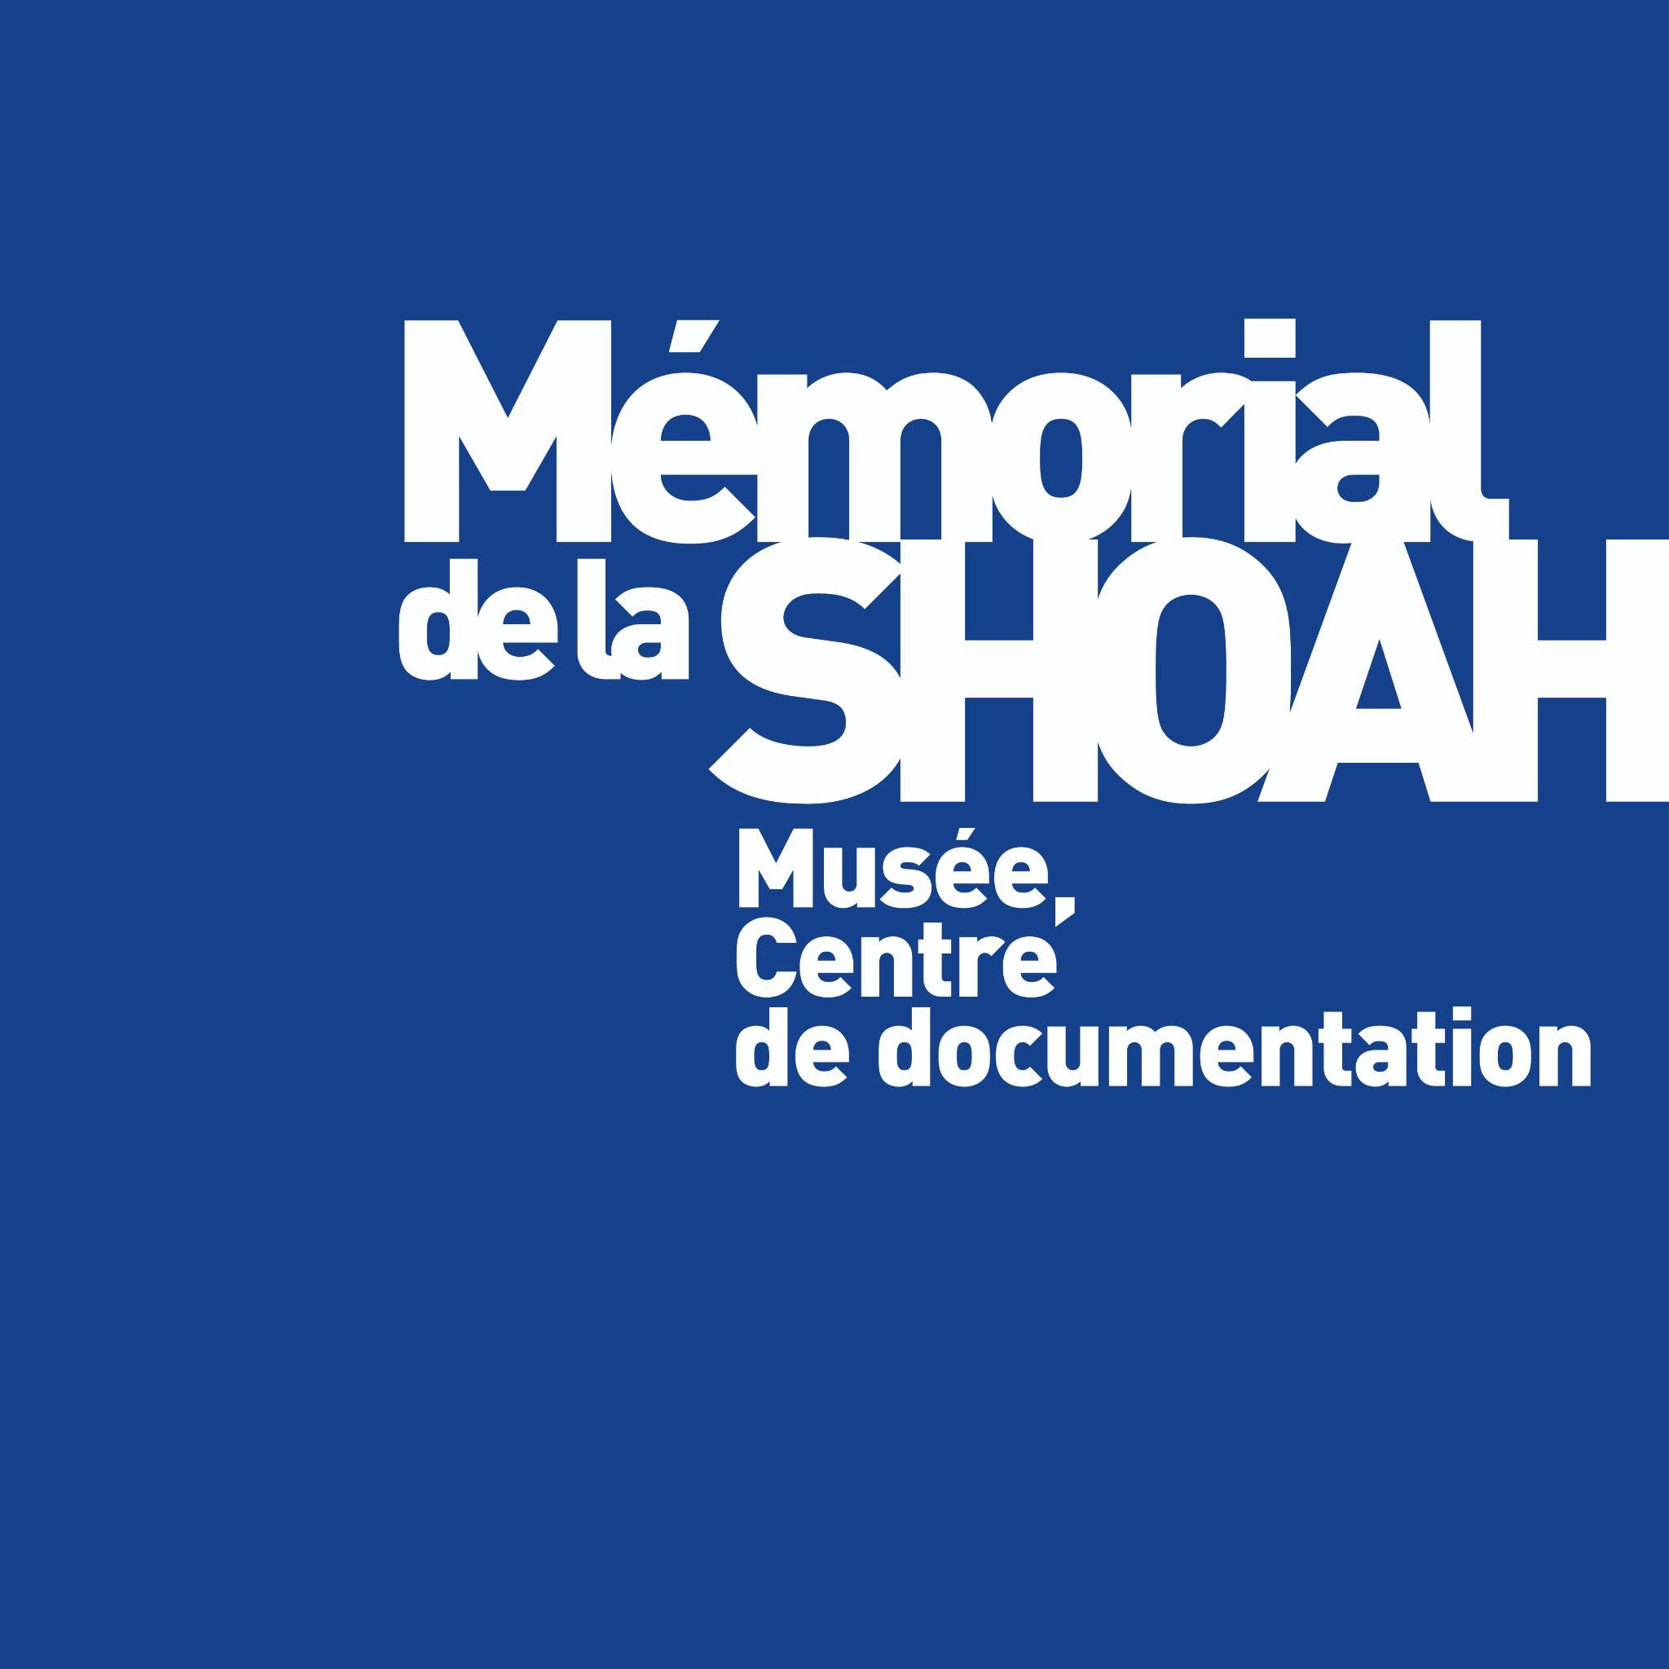
Goran Sadikarijo, Holocaust Fund of the Jews from North Macedonia
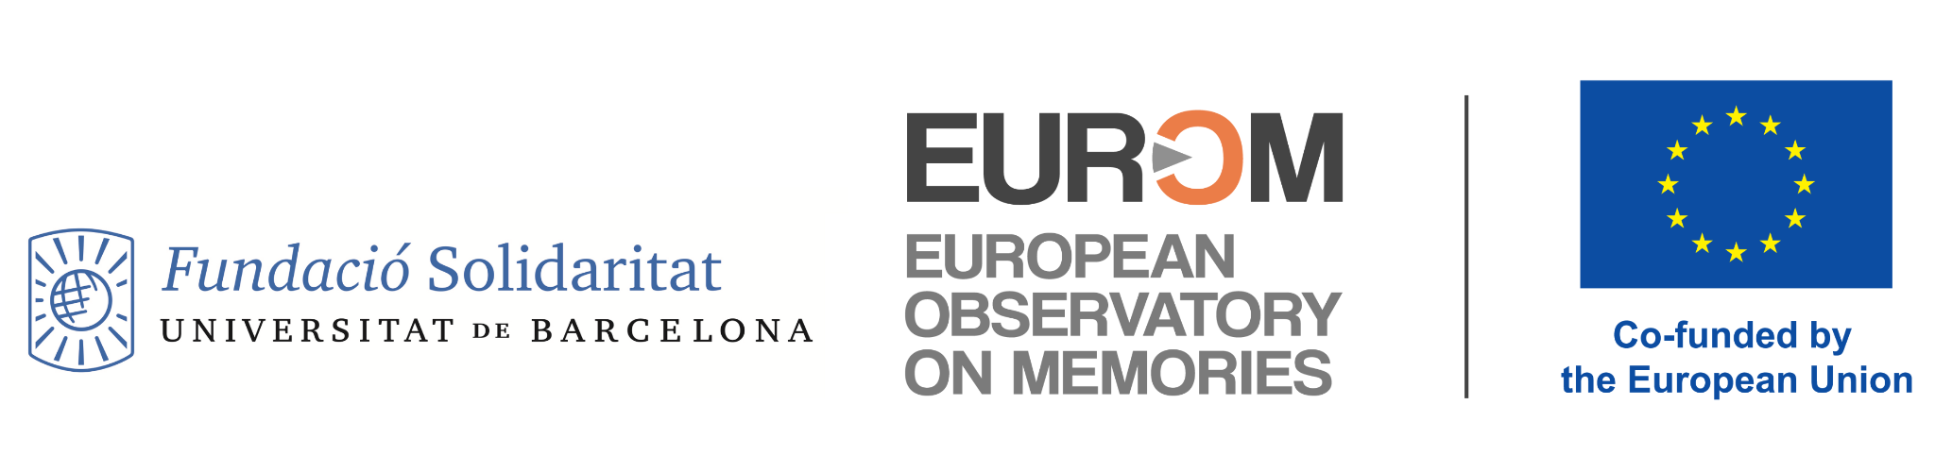
Vassiliki Keramida, Ministry of Education and Religious Affairs of Greece
Bruno Boyer, Mémorial Memorial de la Shoah

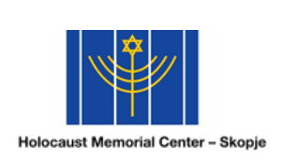


HELLENIC REPUBLIC
MINISTRY OF EDUCATION AND RELIGIOUS AFFAIRS
GENERAL SECRETARIAT FOR RELIGIOUS AFFAIRS

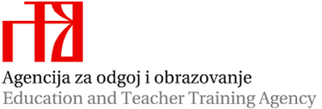
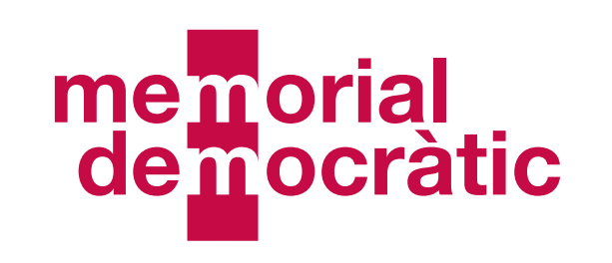

Friday 28th of April
9.00 am |  | Opening  Ice breaking activity
10:00 am |  | Sepharad, the Iberian Península, birthplace of Sephardic jews and the Sephardim, Jews of the Court  To be confirmed
11.30 am |  | Coffee break
11.50 am |  | Workshop 1  Holocaust and cinema  Ophir Lévy, Mémorial de la Shoah  Workshop 2  Sephardic Jews in Greece through family histories  Case study: The Yussurum Family and the Sephardic history of Athens  Anastasia Loudarou, Jewish Museum of Greece
1.30 pm |  | Lunch
2.30 pm |  | Between the Adriatic and the Balkans: Sephardic Jews in Croatia and beyond  Dr. Naida-Michal Brandl, Chair of Judaic Studies University of Zagreb, Faculty of Humanities and Social Sciences  online
3.30 pm |  | Coffee break
3.45 pm |  | Workshop 1  Multiperspectivity – Learning about common history from diverse perspectives  Loranda Miletić, ETTA, Croatia  Workshop 2  Multiperspectivity – Learning about common history from diverse perspectives  Renata Ozorlić Dominić, ETTA, Croatia
5.15 pm |  | End of the working day
7.30 pm

Saturday 29th of April
9.30 am |  | Exclusion of the Sefaradic community, persecution, Inquisition and anti-Judaism  To be confirmed
10.30 |  | Coffee break
11.00 am |  | Historical lecture  Sephardi Jews in Occupied France: from countrymen to second-class citizens.  Dr Santiago López Rodríguez, Postdoctoral Researcher in Holocaust and Genocide Studies | Uppsala University  Workshop 2  Learning activity 2020  Persecution of Jews in early modern times  Marcelo Magalhães, Didac Rubio
12.30 pm |  | Lunch
2.00 pm |  | The Iberian Diáspora: Sephardic Jews, pioneers of globalization  José Alberto Tavim, researcher at the History Centre, Faculty of Letters, University of Lisbon
3.00 |  | Coffee break
3.30 pm |  | The Sefaradic Jews in the constitution of the Israël state  Philippe Boukara, Mémorial de la Shoah
5.00 pm |  | End of the working day

Sunday, 30th of April
9.30 am |  | Site visit (optionnal for the Portuguese educators)  3 paths :  - Alfama district with two memorials of the 1506 massacre  - The place where the Inquisition where established and where the forced conversions took place (theatre)  - Synagog of Lisboa, 1904
11.30 am |  | Debrief of the site visit
12.30 pm |  | Conclusion

